**Homework 5** (**Max Points:100) Due Date: October 15 by 11:59 pm EST**

**Instructions: Each response should be in a .py file. Submit all your code to** [**https://submitty.cs.rpi.edu**](https://submitty.cs.rpi.edu)**.**

**Make sure you print all your output. All variables must be read as user input and printed.**

**Answer the following questions:**

1. **Images:** Download the image named ‘Flower’ from Submitty (Folder : Course Materials/Images) and do the following (To get full credit for this problem submit your final image along with the code): (50 points)
2. Covert the image to grayscale and shrink/scale it to one-eighth the size of the original image (along both x and y axis).
3. Create a new image with 4 copies of this scaled gray image. (Hint: Create a Blank image first then copy and paste the scaled gray image 4 times on it)

Final Image should be:

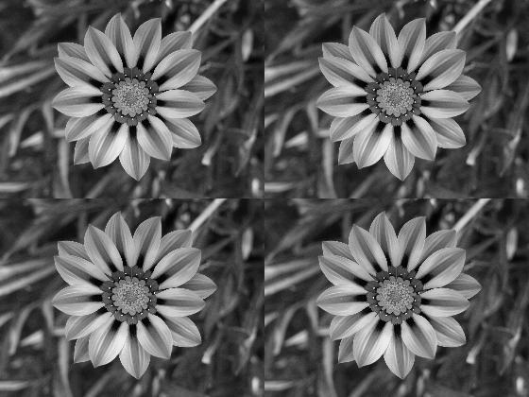

1. **Tuples:**
2. Given an input tuple of two digit integers (of any length), output True if the first and the last numbers have the same digits at the tens place (otherwise output false). (20 points)

Test Cases:

Tens_swap((21,12,45,67,29)) → True

Tens_swap((32, 45, 23)) → False

Tens_swap((76,89,23,45,10,70)) → True

1. Given two points ‘a’ and ‘b’ in the x-y co-ordinate system, write a function called find_dist (a,b) that finds the Euclidean distance between the two points. Both ‘a’ and ‘b’ are tuples such that a=(x1,y1) and b=(x2,y2) and the formula for finding the Euclidean distance is $d=\sqrt{{(x1-x2)}^{2}+{(y1-y2)}^{2}}$. Your output must be an integer (Hint: Use the round function and math module). (30 points)

Test Cases:

print(find_dist((2,3),(5,7))) → 5

print(find_dist((-1,0),(-5,-8))) → 9

print(find_dist((6,-3),(-4,8))) → 15